|  |  |
| --- | --- |
| 1. RGB | C:\Users\John\Desktop\LMS.png  2. LMS |
| C:\Users\John\Desktop\LogLMS.png  3. LogLMS | C:\Users\John\Desktop\LAB.png  4. lαβ |

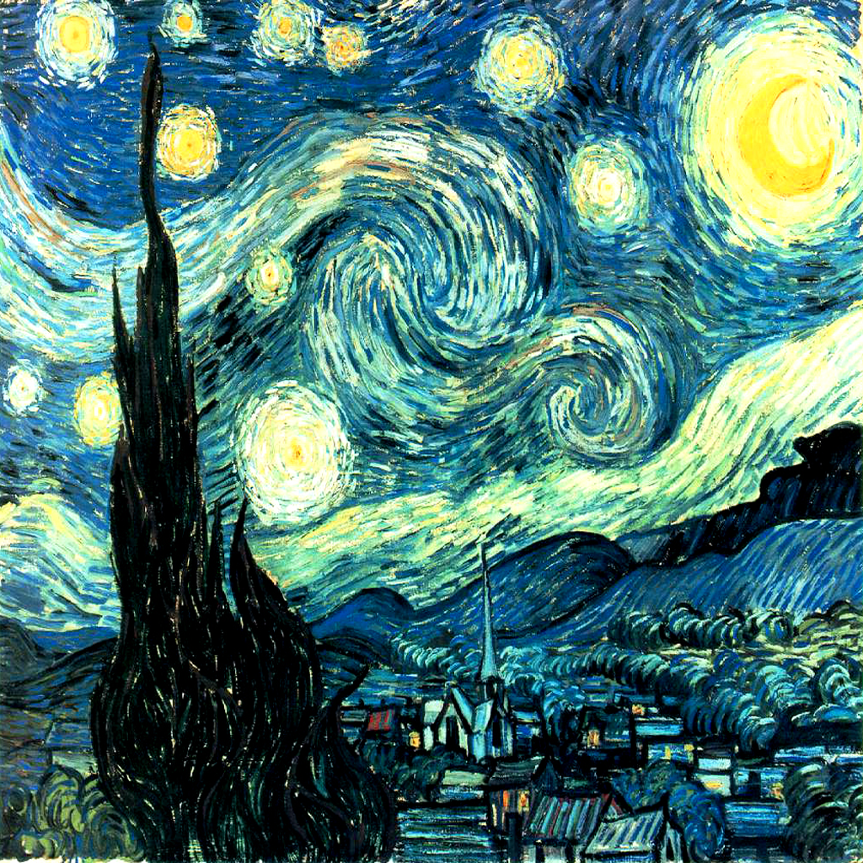

1. RGB image rendered as RGB

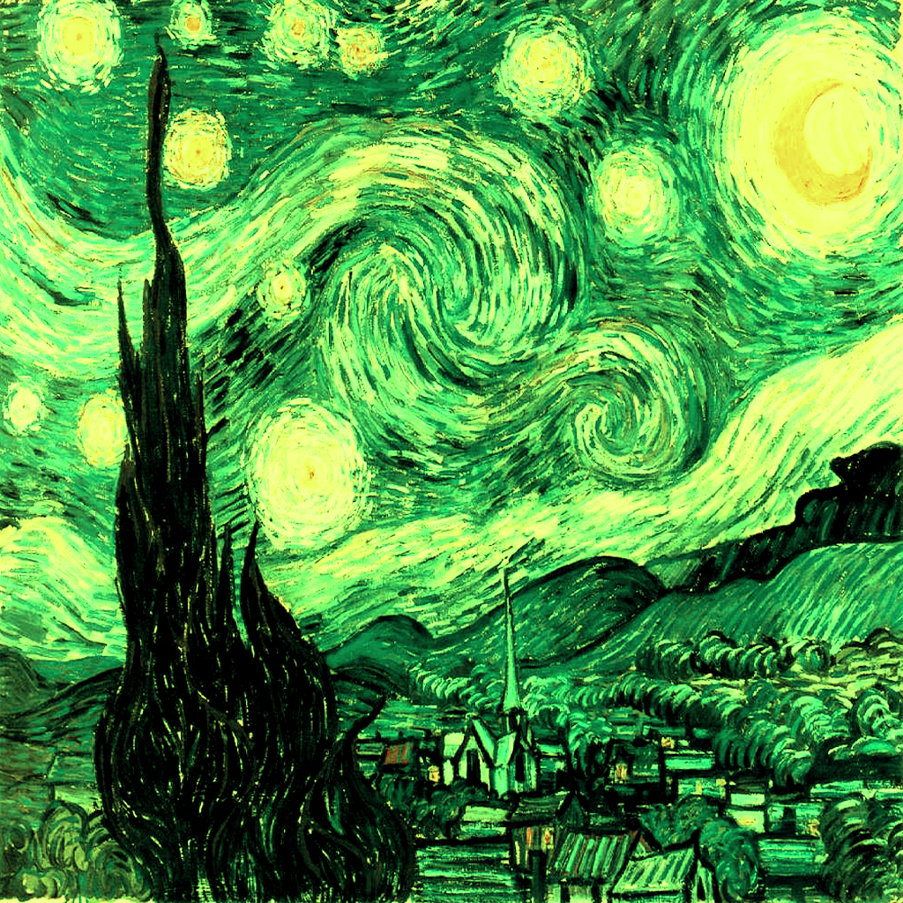

1. LMS Image rendered as RGB



1. LogLMS image rendered as RGB

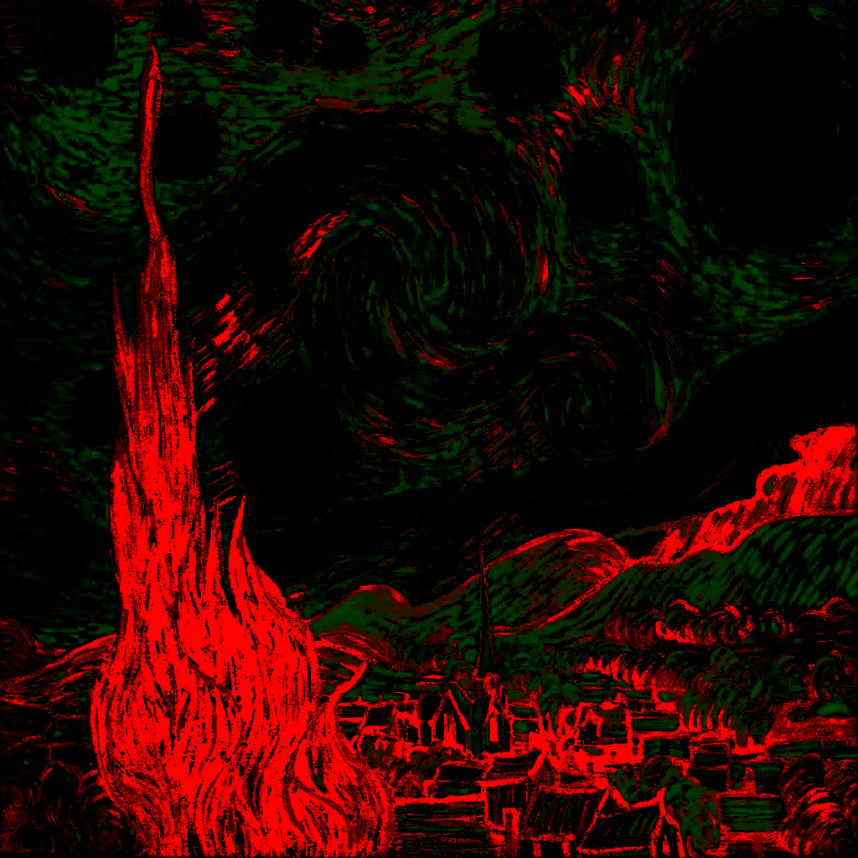

1. lαβ image rendered as RGB